



Technical Design documentation

Document History

|  |  |  |  |
| --- | --- | --- | --- |
| Version | Updated By | Date | Comments |
| 1.1 | Vamshi Vushakola  Rohit John Alex | 29/02/2016 | Initial Draft |
| 1.2 | Vamshi Vushakola  Rohit John Alex | 07/03/2016 | Added Class diagram, Sequence diagram and Use case diagram |
|  |  |  |  |

Document Sign-Off

|  |  |  |
| --- | --- | --- |
| Name | Role | Signature/Date |
| Gyaneshwar Dubey | Manager |  |
|  |  |  |
|  |  |  |

Table of Contents

1. Introduction 4

2. Assumptions 5

2.1 Audience 5

2.2 Supported Environments 5

3. Architectural Overview 6

3.1 Architectural Goals and Constraints 6

3.2 Use-Case View 6

3.3 Logical View 8

3.4 Process View 9

3.5 Implementation View 10

3.5.1 Basic functionality 10

3.5.2 Delayed capturing. 10

3.5.3 Payment with billing agreement. 10

3.5.4 PayPal Payment Transactions Search and Details. 10

3.5.5 Order cancellation. 11

3.5.6 Reauthorization: 11

3.5.7 Refund: 11

3.5.8 Security: Authentication and Authorization 11

4. Functional Overview 12

4.1 Express Checkout 12

4.2 PayPal Express Checkout Shortcut 14

4.3 PayPal Mark 15

4.4 PayPal Credit 15

5. Installation and Configuration 16

6. Installing Add-on 18

6.1 Downloading Add-on 18

6.2 Update localextensions.xml 18

6.3 Run installation command 19

6.4 Main configurations 19

6.5 Rebuild the system 19

6.6 Update 19

1. Introduction

This document is a technical document aiming to guide you through the installation process of PayPal Express Checkout hybris Add-on.

**Affected hybris out of the box applications**

The key criteria are the process of payment registering and/or order management in an application.

|  |  |
| --- | --- |
| **Application** | **Pages and components to affect** |
| B2C Accelerator web | Main page  Mini-cart  **[main] Shopping-cart**  **[main] Payment & Billing Address page**  Final Review page  Confirmation page  Order details page |
| B2C Accelerator mobile | The same as previous |
| CS Cockpit | Find PayPal Transaction  Orders->Payment Transactions  Orders->Payment Transactions->Additional transaction details  Orders->Billing Address  Orders->Payment Details |
| hMC (hybris Management Console) | Orders->Payment and Delivery  Orders->Payment and Delivery->Administration  System->Cronjobs |
| hAC (hybris Administration Console) | Platform->Configuration->keys starting from Paypal. |
| Back Office Cockpit | Orders->Payment and Delivery |

1. Assumptions

This section describes prerequisite actions needed and conditions to be met before installing Add-on.

## Audience

The expected audience for this document is technical specialists involved in PayPal integration into hybris. These specialists are expected to be familiar with hybris environment and setting extensions for it.

## Supported Environments

Add-on was designed against versions 5.2-5.4 of hybris.

The main testing was conducted in versions 5.2.0.4 and 5.4.0.0

Users on versions below 5.2, please consider the following: the add-on may work on 5.0/5.1 (and we expect it to work), but it was not tested on these versions. It’s not expected to be working on versions prior to 5.0.

1. Architectural Overview

## Architectural Goals and Constraints

The main goal for PayPal-hybris integration is end-to-end solution which can be used by merchants and developers with the most recent hybris platforms. This solution should be easy to plug in, configure, and extend for particular business needs.

## Use-Case View

General PayPal Express Checkout flow was used in the integration and it is depicted on the diagram below:

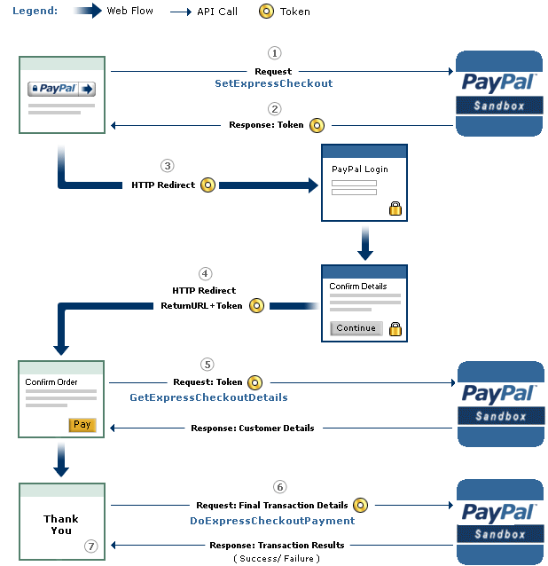

Figure 1. PayPal Express Checkout flow

The following implementation was chosen:

1. PayPalHopPaymentRequestController sends a call to PayPal API server with SetExpressCheckout API call where we pass cancel and return URLs, payment action, solution type and so on.
2. If the call was successful, controller saves PayPal token in cart’s payment info and perform redirect to PayPal server.

3. When user fulfills all the required information and returns back on hybris server, PayPalHopPaymentResponseController copies data from PayPal response into cart and opens summary page.

4. PayPalCheckoutFacade processes payment authorization and calls DoExpressCheckoutPayment.

5. At the end, fulfillment process is started and DoCapture is called from order handling chain.

## Logical View

The solution consists of three modules:

**Paypal** – module contains business logic to communicate with PayPal through the classic API (based on SOAP protocol).

**Paypaladdon** – module that was built on hybris AddOn concept which was introduced in 5.0 hybris version. This allowed us to add functionality to B2C Accelerator without touching the core code base. That approach is in accordance with hybris best practice recommendations when logic and storefront-related features are in separate extensions.

**Paypalcscockpit** – module that extends hybris Customer Service Cockpit with PayPal specific functionality.

The modules include the following architecturally significant design packages:

|  |  |
| --- | --- |
| **PayPal** | |
| com.ebay.api | SOAP Java client generated from the PayPal WSDL. |
| com.paypal.hybris.commands.impl | Implementation of payment commands such as CaptureCommand. |
| com.paypal.hybris.converters | Classes to convert and populate data transfer objects from hybris to PayPal and vice versa. |
| com.paypal.hybris.converters.populators |
| com.paypal.hybris.jobs | Delayed capturing and billing agreement handling services. |
| com.paypal.hybris.service | Central PayPal service component. |

|  |  |
| --- | --- |
| **paypaladdon** | |
| com.paypal.hybris.addon.facades | Extension of B2C accelerator facades. |
| com.paypal.hybris.addon.controllers.pages | Page controllers. |

|  |  |
| --- | --- |
| **paypalcscockpit** | |
| com.paypal.hybris.cscockpit.widgets.controllers | Widget controllers. |
| com.paypal.hybris.cscockpit.widgets.renderers.impl | PayPal specific widgets. |

## Process View

Interaction diagram demonstrates the add-on layering approach:

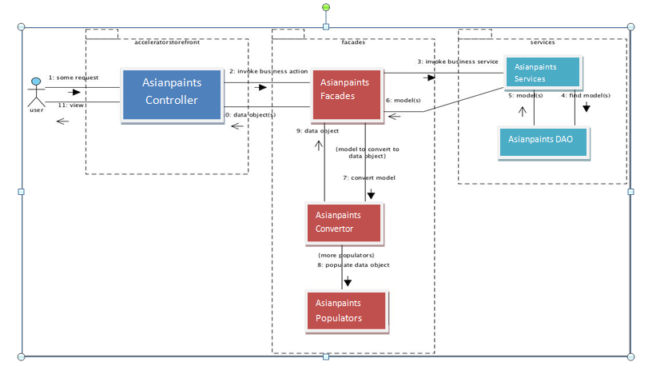  
Figure 2. Interaction diagram

1. Customer initiates new request to PayPal with PayPalHopPaymentRequestController.

2. Controller uses PayPalPaymentFacade to perform actual call to PayPal using PayPalPaymentService. To convert data from hybris DTO to PayPal SOAP and vice versa converters and populators are used.

3. Finally, PayPalPaymentService uses SOAP client to communicate with PayPal server.

## Implementation View

### Basic functionality

Basic functionality was implemented with **HOP approach** provided by hybris B2C accelerator to add new payment method.

PayPalHopPaymentRequestController initiates request to PayPal using SetExpressCheckout API call and PayPalHopPaymentResponseController processes PayPal response with GetExpressCheckout API call. Finally, PayPalCheckoutFacade authorizes payment with DoExpressCheckout API call.

### Delayed capturing.

By default, all orders were captured automatically using payment’s CapturingCommand. To allow developers to change that behavior we’ve introduced com.paypal.hybris.commands.strategy.CapturingStrategy as it allows to demonstrate both immediate and delayed capturing.

After add-on is installed the default payment strategy is now the following:

1. Express Checkout ends with Authorization of payment

2. Orders with Order Total less than 100 in currency of purchase are captured immediately after checkout is finished.

3. Orders exceeding the threshold of 100 are not captured automatically. They should be captured with CronJob.

Remember that you can always return to the basic capturing flow. See the details in the Installation Guide.

### Payment with billing agreement.

Orders that have been placed using billing agreement ID are processed by com.paypal.hybris.jobs.BillingAgreementJob.

In addition to PayPal Express Checkout functionality integration offers order handling functionality that is available in **CS Cockpit**:

### PayPal Payment Transactions Search and Details.

PayPalTransactionSearchWidgetRenderer widget is used to display search results of payment transactions. com.paypal.hybris.cscockpit.services.search.impl. PayPalTransactionSearchService is used to retrieve payment transactions data, build data model, and link appropriate order.

### Order cancellation.

Order cancellation is implemented in com.paypal.hybris.ordercancel.PayPalCancelRequestExecutor which extends default ImmediateCancelRequestExecutor. Do Void API is used.

### Reauthorization:

Order **reauthorization** is implemented in com.paypal.hybris.reauthorization.impl.PayPalOrderReauthorizationServiceImpl using DoReauthorization API.

### Refund:

Order **refund** is defined in com.paypal.hybris.refund.PayPalRefundService which extends DefaultRefundService. RefundTransaction API is used.

### Security: Authentication and Authorization

In order to work with PayPal, valid credentials including password and signature need to be obtained and used:

# Credentials

paypal.username=2krauchanka-facilitator_api1.gmail.com

paypal.password=9RYSV6BVZCASDU8U

paypal.signature=A11J4d0T.qZ-uHAPOnuQORa6vqjMAXTfcQnMVAQDODt20ucRYreACouj

Note that this is just an example of credentials, don’t try to use them for any purposes.

Configuration with PayPal is covered in Installation Guide in the ‘Configuration with PayPal’ section.

1. Functional Overview

## Express Checkout

Add-on offers Express Checkout to merchants through the use of the “Check Out with PayPal” shortcut button and Express Checkout Mark. The solution is implemented into out-of-the-box B2C hybris accelerator (both cart and mini-cart are affected).

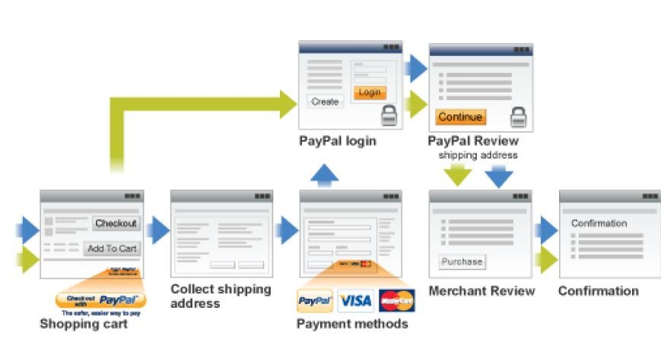

Figure 4. Two implemented flows of payment with PayPal

Assuming buyer has a PayPal account, in the figure above, the flow with green arrow shows the flow for Express Checkout when Buyers initiate the Express Checkout flow on the shopping cart page or in-mini cart by clicking the Checkout with PayPal button. And the flow with blue arrow shows the flow for Express Checkout when Buyers initiate the Express Checkout flow on the payment methods page by selecting PayPal as the payment option.

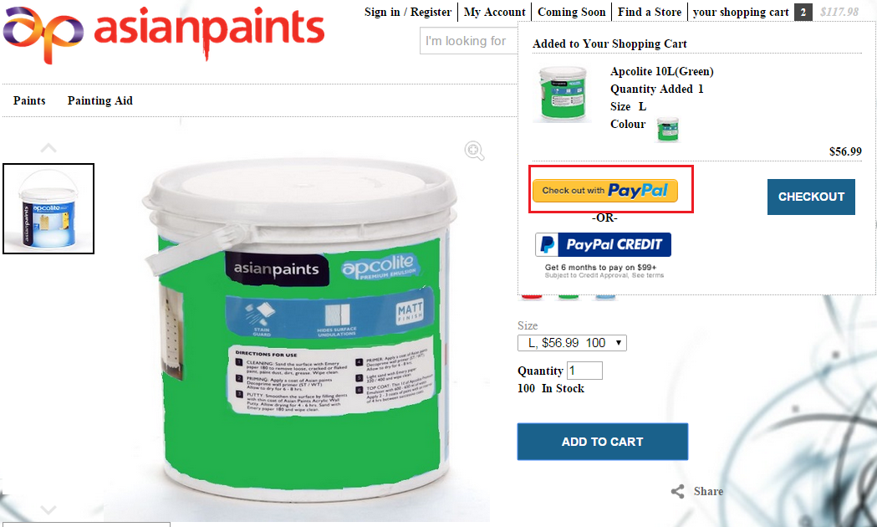

Figure 5. PayPal Shortcut in mini-cart

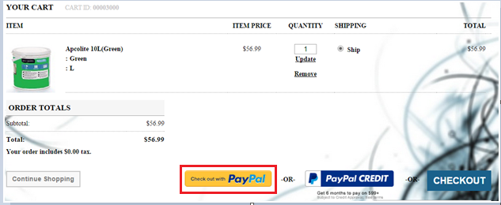

Figure 6. PayPal Shortcut in shopping cart

## PayPal Express Checkout Shortcut

1. The PayPal Express Checkout Shortcut will appear on the Shopping Cart page of hybris B2C accelerator and also in mini-cart.

2. If a customer clicks on it, they will be redirected to PayPal where they will see the PayPal login page.

3. Once logged in they will see the PayPal Review page. On the Review page they can either keep the defaults or change their funding source and shipping address.

4. When they click continue they will be redirected back to the hybris B2C accelerator review page.

5. Once on order review page they can click “Place order” to process their order and payment.

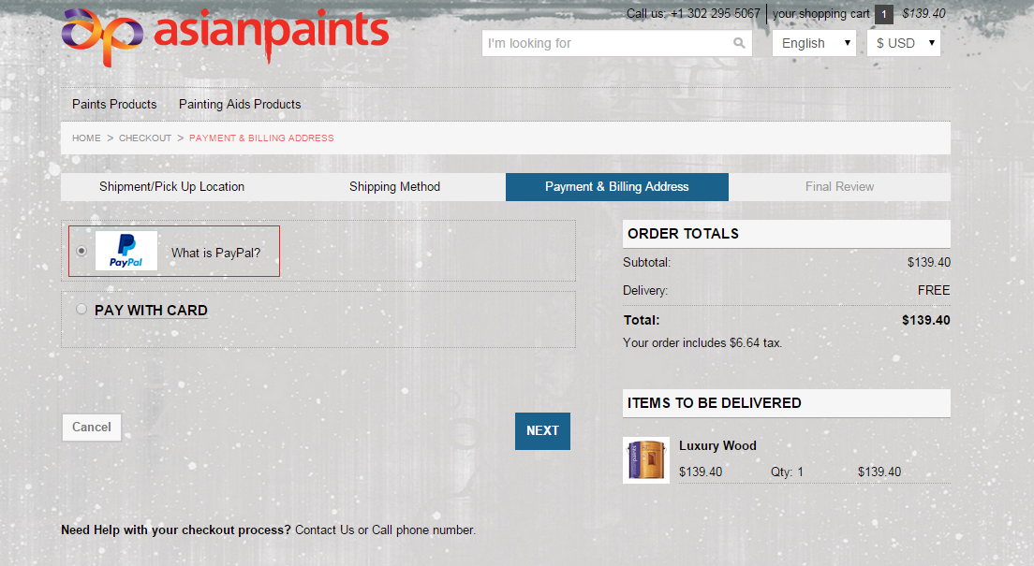

Figure 7. PayPal Mark on Payment Details page

## PayPal Mark

PayPal Mark allows to choose PayPal as the payment option after user passed the previous checkout steps within the merchant’s site.

1. The PayPal Mark logo will appear on the Payment Details page.

2. If a customer selects the PayPal radio option and clicks proceed they will be redirected to the PayPal login page.

3. Once logged in they will see the PayPal Review page. On the Review page they can either keep the defaults or change their funding source and shipping address.

4. When they click continue they will be redirected back to the hybris B2C accelerator review page.

5. Once on order review page they can click “Place order” to process their order and payment.

## PayPal Credit

The solution offers PayPal Credit to Merchants through the use of the “PayPal Credit” button both in cart and mini-cart.

If B2C users choose checkout process with this button then he is redirected to PayPal and PayPal credit is selected as funding source. The rest of checkout process stays the same.

Please note the following:

1. Orders which are $99 USD or more can be purchased with PayPal credit.

2. PayPal Credit is available for US only.

PayPal Credit Financing Banner appears in the shopping cart of accelerator as a part of implementation.

1. Installation and Configuration

For development and testing purposes you firstly need to register PayPal Sandbox business account at https://www.developer.paypal.com/

You will also need a personal PayPal Sandbox account to make test payments from it.

**Access Developer Portal and Create a PayPal Sandbox Account**

1. Go to http://www.developer.paypal.com and log in (Production PayPal credentials are required to access the developer portal)

2. Click **Dashboard** link at the top of the page

3. Click **Accounts** in the Sandbox section

4. You can now create a Sandbox account to receive test API credentials. Click **Create Account** at the top of the page and populate the following fields:

|  |  |
| --- | --- |
| **Account type** | Tick either the **Personal** or **Business** radio button. |
| **Email address** | The email address doesn't need to be a real email address; the Sandbox doesn't send any email outside of the Sandbox environment. Email to Sandbox accounts, generated as a result of your test API requests, are listed on both the Notifications tab on the Developer site, as well as on the Sandbox test site.  Use the assigned email value to reference this test account in your API calls, and to log in to the Sandbox site when you want to review the details associated with the account. |
| **Password** | The password must be 8-20 alpha-numeric characters in length. Use the password to log in to the Sandbox site as the test account. |
| **First and Last names** | The optional name fields accept alpha-numeric characters. |
| **PayPal balance** | While this field is optional, it's a good idea to create test accounts with positive bank balances. Enter an integer value between 1 and 5000. |
| **Bank Verified Account** | You should create both *Verified* and *Unverified* test accounts so you can fully test your application. |
| **Select Payment Card** | Test payments made with different payment cards by selecting either **Discover** or **PayPal**.  *(Personal accounts only.)* |
| **Credit card type** | You must select a single credit card type for each test account. The Sandbox associates a mock credit card number with the account. |
| **Log in with PayPal** | Tick the **I want to add Log in with PayPal to my site** box and complete the following fields to enable Log In with PayPal testing:  **1. Display name**  **2. Return URL**  **3. Privacy policy URL**  **4. User agreement URL**  *(Business accounts only.)* |

5. Once the follow details have been entered click the **Create Account** button

6. To locate the API credentials for your Sandbox PayPal account, click on the account you would like to view credentials for then select the **Profile** link.

7. Navigate to the API credential tab and copy your credentials highlighted below:



**Figure 1. PayPal business account details for Add-on configuration**

1. Installing Add-on

## Downloading Add-on

1. Download adapter archive from the hybris marketplace

2. Unpack archive and place folders **paypal**, **paypaladdon** and **paypalcscockpit** into **..\bin\custom**



**Figure 2. Add-on repository location**

## Update localextensions.xml

1. Check the presence of **<extension name="addonsupport" />**

2. Add extensions **<extension name="paypal"/>**

**<extension name="paypaladdon"/>** and

**<extension name="paypalcscockpit"/>**

3. Check the presence of target storefront extension

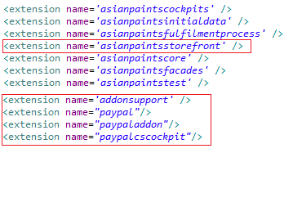

**Figure 3. Example of configured localextensions.xml**

## Run installation command

1. Stop hybris if it’s running with Ctrl+C

2. Run **setantenv.bat** if it was not applied in this terminal

3. Go to **..\bin\platform** and run installation command:

**ant addoninstall -Daddonnames=paypaladdon -DaddonStorefront.asianpaintsstorefront= asianpaintsstorefront**

The output should end with BUILD SUCCESSFUL

## Main configurations

1. Go to .**.\bin\custom\paypal\project.properties**

2. Find and update the following configurations: **paypal.username**, **paypal.password**, **paypal.signature** and **paypal.seller.email** with your API credentials from PayPal business account.

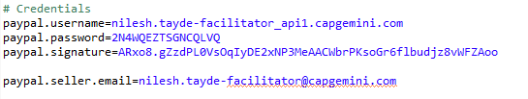

**Figure 4. Example of configured project.properties**

## Rebuild the system

## Update

At this step you may make **full initialization** through hAC if you use clean hybris for testing purposes. And that is 1 sufficient step to finish add-on installation.

If you can’t perform full initialization then you need to make more complicated update:

1. Go to hAC->Platform->Update

2. Choose 4 update options **Update running system**, **Clear the hMC configuration from the database**, **Create essential data**, **Localize types**

3. Choose add-on components to update: **paypal**, **paypaladdon**, **paypalcscockpit**

4. Then make update

5. After update finishes go to **Console**->**Impex Import**.

You must insert script here. You should use one of ready scripts (if it is accelerator based installation) or customize one for your content catalog.

You can find ready scripts in add-on files: **..\bin\custom\paypaladdon\resources\paypaladdon\import\contentCatalogs\**

For example, during testing we used **cms-content** and **cms-mobile-content** from **asianpaintsContentCatalog**.

6. Import content

7. Go to hMC->Catalog->Catalog Management Tools->Synchronization

8. Choose Source Catalog Version and execute Synchronization

